Why we write Build().Perform() ??

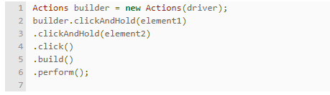

In the above code we are performing more than one operations so we have to use build() to compile all the actions into a single step. Thus build() method is used compile all the listed actions into a single step. We use build() when we are performing sequence of operations and no need to use if we are performing single action.